Bus Operator Refresher Fire and Evacuation Procedure

Bus Engine Bay Fire Suppression Equipment
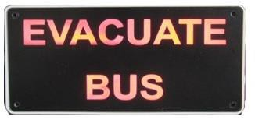
Commence the evacuation procedures immediately

Stop the Engine but leave the ignition on
Pull over as quickly and safely as possible. If possible avoid stopping in tunnels, interchanges, bus stations, outside service stations, schools, hospitals or congested areas. If the fire is getting out of hand, you will have to pull over immediately. If you have to stop in a busway tunnel, try to stop before one of the yellow exit doors. This is so your passengers will not have to walk past the burning engine bay to exit the tunnel. Once stopped, apply your park brake, put the bus in neutral, and turn on your hazard lights. Stop the engine but leave the ignition on so that you can still operate the radio and doors. Stopping engine also stops fuel from being pumped to the engine. If you are driving a gas bus pull the emergency gas shut off handle. It will isolate the gas supply from the engine.

Alert your passengers and NCC
Inform your passengers and open both front and rear doors and evacuate them to a safe location, preferably at least 200m forward of the bus if possible. Be mindful of your location, any dangerous goods in the area, structures etc.
You will need to give clear directions to your passengers, don’t panic, remain calm and be assertive. You may need to consider other evacuation alternatives including breaking windows or using roof hatches.
If it is safe to do so call NCC by pressing “1” on the radio and advise them of the situation. Do not put yourself in danger, if it is not safe, leave the bus and try to advise NCC from another bus radio or mobile phone. Give NCC as much information as possible regarding your location and the severity of the fire. NCC will contact emergency services immediately. Help will be on the way.

Finalise, turn off ignition
If safe to do so physically check the bus is empty. Turn off your ignition and main switches. This will further reduce a fuel source for the fire. If the automatic detection system has not activated there will be no beeping alarm or flashing red LED lights on the monitoring unit. If you are certain that there is a fire in the engine bay, manually activate the powder delivery at this time.

Exit the bus and stay clear
Collect the fire extinguisher and evacuate the bus, making a final check all passengers have exited. You may need to render assistance to slower passengers. eg. disabled or elderly passengers.
Move at least 200m away from the front of the bus. If it is safe to do so (and the fire is contained) attempt to extinguish the fire by using the fire extinguisher or any other means available to you at the time. i.e. fire hose or garden hose.

Bus Operator Refresher Fire and Evacuation Procedure

Opening the rear hatch may mean a burst of fire on your face and body

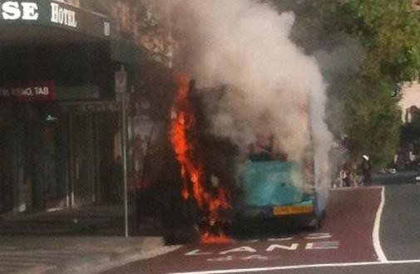
Risk
If it looks too big to you or the fire is already
outside the engine bay zone… it is too big.
If you cannot approach within 2-4 metres because of heat… it is too big.

Observe
Where is the fire and how will you attack it?
You may be able to use the extinguisher through the vents or under the body skirt.
You will get blow back from the powder if you get too close to a surface. A 2.5 KG extinguishing will discharge in 10 – 15 seconds, so consider your approach

.

Prepare
Pick up the extinguisher, invert and shake briefly to loosen the powder.

Start the PASS method

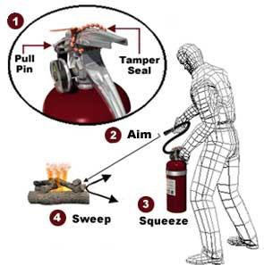Pull (Pin)
Pull pin at the top of the extinguisher, breaking the seal. When in place, the pin keeps the handle from being pressed and accidentally operating the extinguisher. Immediately test the extinguisher. (Aiming away from you) This is to ensure the extinguisher works and also shows the operator how far the stream travels.

Act

Aim
Approach the fire standing at a safe distance, (3-4 metres). Aim the nozzle or outlet towards the base of the fire.

Squeeze
Squeeze the handles together to discharge the extinguishing agent inside. To stop discharge, release the handles.

Sweep
Sweep the nozzle from side to side as you approach the fire, directing the extinguishing agent at the base of the flames. After a fire is extinguished, probe for smouldering hot spots that could reignite the fuel.

Do not attempt to restart the bus.

Bus Operator Refresher Fire and Evacuation Procedure

Fire Suppression System
Normal day to day operation with ignition turned on

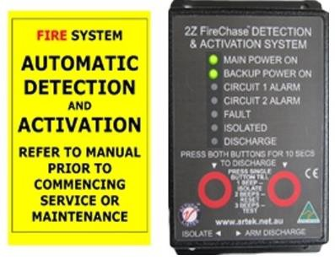Normal Operation
On most days you will not be required to do anything other than monitor the audio alarms and warning lights. The system will alert you to any fires or faults by activating the audio alarms and warning lights. After the bus has been standing with the ignition off for 30 minutes, the system will turn itself off. There will be no LED lights visible on the Monitoring Unit.

When the ignition is turned on, there will be two short beeps and two green LED lamps will be displayed.

A steady audio alarm and Amber Lamp on indicates a fault
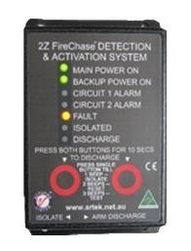
Fault Detected Detected
The system also has an alarm to alert the driver of a fault. If the tone is steady and an amber light is displayed on the monitoring unit, it simply means that there is a fault and there is no need to evacuate the bus. You cannot clear this fault. Contact NCC for assistance. The position of this monitoring unit will in most cases be above the driver’s head. In a small number of buses however, it will be in the lower dash.

Fire or Fault a long continuous alarm
Two red lights must evacuate
It is important to understand the operation of the LED lamps on
the monitoring unit if you hear an alarm, look at the unit to see if there is a fire or a fault with the system. If the alarm is continuous and there is one red LED lamp displayed then it could be a fault or fire. You will need to investigate and act. If the alarm is beeping and there are two red LED lamps displayed on the monitoring unit, there is a fire and the system will deliver the powder in 30 seconds.
Remember, a loud beeping alarm with corresponding red LED lamps displayed always means a fire and you will need to evacuate your passengers immediately.

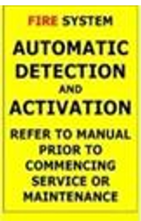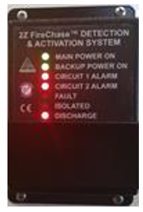

Bus Operator Refresher Fire and Evacuation Procedure

Manual Release point
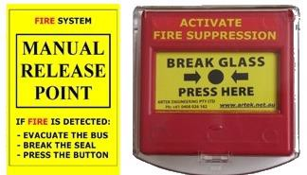
The Manual Release Point consists of two items: a yellow decal with instructions and a red Manual Release Point box labelled “Activate Fire Suppression” located in most buses above the drivers head. There are a small number of buses where this unit is in the lower dash.
To operate the system manually, the driver will need to lift the clear plastic lid, and then press the dot in the centre between the two arrows until the glass breaks. This will activate the system.

The glass can be broken safely with the driver’s thumb. As the glass is covered with plastic, it will not cut the driver’s thumb when it breaks.
It is important to note that this process will almost certainly never be required as the system should activate automatically in the event of an engine bay fire.
Don’t forget, fires in other areas of the bus will not be extinguished by this system. You will need to use the fire extinguisher in the driver’s compartment.
If you are not certain that there is a fire, do NOT activate the system manually by breaking the glass. Wait and monitor the system and if a fire becomes evident, you can then manually activate the system by breaking the glass.
On any fire alarm and red light on the monitoring unit, or any indication of smoke and/or fire you should evacuate your passengers immediately.

When the bus is shut down
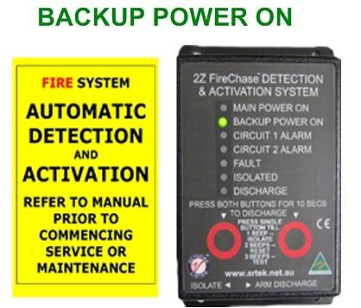The system has a safety feature which allows for the monitoring for engine bay fires to continue until 30 minutes after the bus has been shut down.
BACKUP POWER ON

The engine bay will therefore be monitored for fires as the engine cools. The system will then shut down after 30 minutes.
Don’t be alarmed if a green LED lamp remains on the monitoring unit after you completely shut down the bus.

Additionally if you arrive at a bus and you see a green “Battery Power On” lamp displayed on the Monitoring Unit, it means that the bus was last shut down less than 30 minutes ago and can still be used as normal.

Bus Operator Refresher Fire and Evacuation Procedure

Fire Suppression System Layout

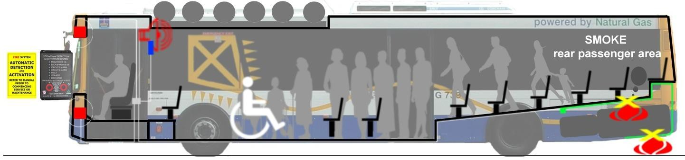

Fire detected
If fire originated in your bus
If fire originated from an external source in QSBS, KGBS or Busway
Stop the bus
Remain on alert, wait for and act on instructions from NCC
Alert your passengers and advise NCC of the situation
Receive all clear
Isolate the gas supply and turn off ignition
Return to normal service
Evacuate forward of the bus and stay clear

